“PARKING ASSISTANT”

Submitted in partial fulfilment of the requirements of the degree of Bachelor of Engineering
by

Name of the Student | IEN No.
Om Ghag | 12212039
Sana Girish | 12242001
Jeet Gor | 12212027

Under the Guidance of
Dr, Sanjay Sharma


Department of Computer Engineering New Horizon Institute of Technology and Management

University of Mumbai
2023-2024


Department of Computer Engineering New Horizon Institute of Technology and Management University of Mumbai

CERTIFICATE

This is to certify that the mini-project 1A entitled (“PARKING ASISTANT”), (Group No. 8) of

Name of the Student | IEN No.
Om Ghag | 12212039
Sana Girish | 12242001
Jeet Gor | 12212027

has satisfactorily completed of mini-project 1A in partial fulfilment of the requirement for the award of the Degree of Bachelor of Engineering in “Computer Engineering”.

Mini-Project Guide

Head of Department Principal


Department of Computer Engineering New Horizon Institute of Technology and Management University of Mumbai

Mini Project-1A Approval for S.E.

This project report entitled (“PARKING ASSISTANT”) by (Om Ghag,Sana Girish,Jeet Gor) is approved for the degree of Bachelors in Computer Engineering, 2023-24

Examiners:

- Name: Sign with Date:

- Name: Sign with Date:

Date:
Place:

Department of Computer Engineering New Horizon Institute of Technology and Management University of Mumbai

Declaration

We declare that this written submission represents our ideas in our own words and where others' ideas or words have been included, we have adequately cited and referenced the original sources. We also declare that we have adhered to all principles of academic honesty and integrity and have not misrepresented or fabricated or falsified any idea / data / fact / source in our submission. We understand that any violation of the above will be cause for disciplinary action by the Institute and can also evoke penal action from the sources which have thus not been properly cited or from whom proper permission has not been taken when needed.

1.

2.

3.

Date:


Department of Computer Engineering New Horizon Institute of Technology and Management University of Mumbai

Acknowledgement

We would like to express our gratitude to our guide Dr Sanjay Sharma for invaluable guidance and mentorship during the course of this project. Your expertise and unwavering support have played a pivotal role in its successful completion. We are deeply grateful to our principal Dr Prashant D Deshmukh, head of our department Dr Sanjay Sharma and other faculty members for their suggestions and encouragement. It helped us increase our knowledge and skills. Thank You everyone.

1.

2.

3.

Date:

Abstract

Nowadays parking is the critical issues smart city, due to parking problem, traffic problems are increased, the proposed smart parking system implemented using the Android Application that provides an easy way of booking the parking slots through an application system to avoid the problem of traffic compaction which unnecessarily consume customers time, this provides the easy reservation system for parking. In this application the user can view various parking slots and check about the availability. Whenever a customer books a particular slot it will be marked red and all the available will be blue. Hence this application reduces the user's effect and time of searching the parking she and avoid traffic wing the internet of things

List of Figures
Fig. No. Caption Page No.

Fig 3.1 | Main activity | 5
Fig 3.2 | Maps activity | 6
Fig 4.1 | Result | 7

CHAPTER 1 INTRODUCTION

Too many cars, too much traffic and there is no enough parking area. This is the situation which is seen in most of the metropolitan cities today. People keep on roads searching for a parking space to park their vehicles especially at peak hours of time. Our proposed system presents a smart parking system that regulates a number of vehicles to the nearest parking space at any given time based on the parking space availability Car Parking System (CPS) is implemented using the Operating System Android. The user requests the Parking Control Unit to check the status of available parking shots. As soon as the user request, all the available free slots are displayed to the user. If the availability of parking space is confirmed The vehicle follows its path towards the starting of the packing area.

The purpose of the proposed system to :-

⚫To increase efficiency of the current parking system

⚫To track the nearest car parking place via maps

⚫To book available free parking space

⚫To reduce time and efforts of drivers

CHAPTER 2 LITERATURE REVIEW

Parking assistance systems have become increasingly important in the modern world due to the ever-growing urbanization and the associated scarcity of parking spaces. These systems, often in the form of mobile applications, offer a wide range of features to aid drivers in finding, reserving, and navigating to parking spots, contributing to reduced traffic congestion, fuel consumption, and stress. This literature review provides an overview of the key components and benefits of parking assistance system apps, highlighting recent developments and research findings in the field.

1. **Parking Challenges in Urban Areas**
Urbanization has led to a surge in the number of vehicles on the road, resulting in severe parking challenges, especially in densely populated cities. Finding a parking spot quickly and efficiently has become a daily struggle for many drivers, leading to traffic congestion and increased greenhouse gas emissions.

2. **Mobile Parking Assistance Apps**
Mobile parking assistance applications offer a convenient solution to this problem. These apps provide real-time information about available parking spaces, their locations, and pricing. They allow users to reserve parking spots in advance, reducing the uncertainty and stress associated with finding parking.

3. **Types of Parking Assistance Apps**
Parking assistance apps can be categorized into three primary types:
- **Navigation Apps:** These apps provide turn-by-turn directions to the nearest available parking spots and help drivers reach their destination with ease.
- **Reservation Apps:** These apps allow users to pre-book parking spaces, ensuring a spot is available when they arrive, saving time and frustration.
- **Information Apps:** These apps offer information about parking availability, pricing, and restrictions, helping users make informed decisions.

4. **Technological Components**
Parking assistance apps rely on various technologies, including GPS, sensors, and data analytics. They access real-time data from parking lots and garages, monitor on-street parking, and use algorithms to predict parking availability.
5. **Benefits of Parking Assistance Apps**
Research has demonstrated several benefits of parking assistance apps:
- **Reduced Traffic Congestion:** By guiding drivers directly to available parking spots, these apps can reduce unnecessary circling and congestion.
- **Time and Fuel Savings:** Drivers waste less time and fuel searching for parking, leading to cost savings and a reduction in carbon emissions.
- **Improved User Experience:** Users experience less stress and frustration when parking, enhancing the overall driving experience.
- **Optimized Space Utilization:** Parking facilities can manage their spaces more efficiently, reducing the need for new infrastructure.

6. **Challenges and Future Directions**
While parking assistance apps offer numerous advantages, they also face challenges related to data accuracy, privacy, and integration with smart cities. Future research should focus on improving the accuracy of parking data, addressing privacy concerns, and enhancing the connectivity between parking apps and smart city infrastructure.

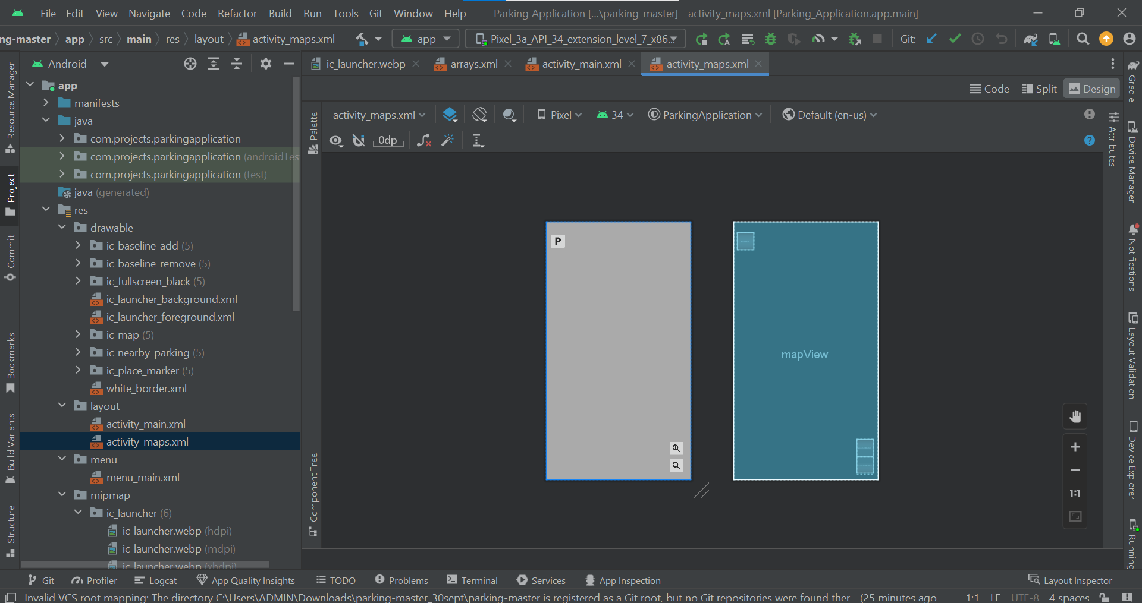
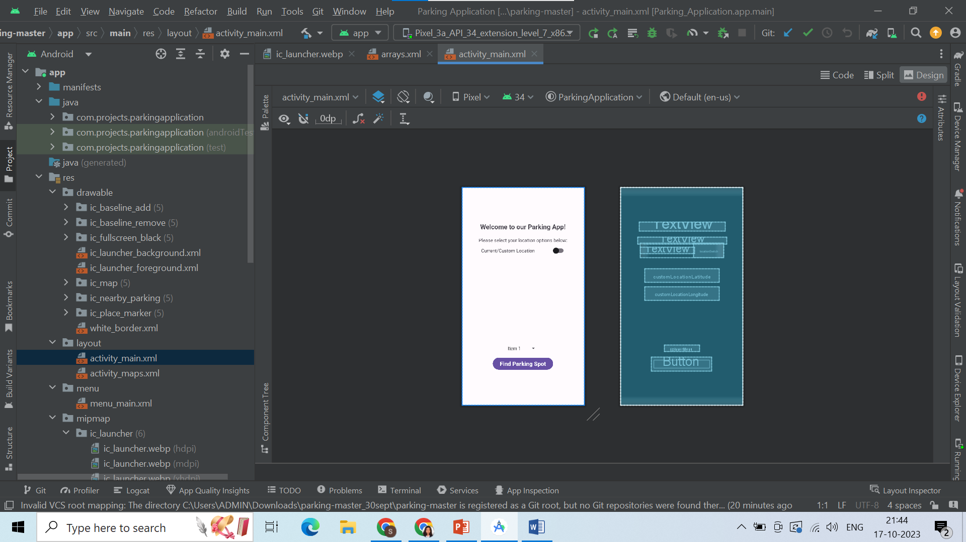
CHAPTER 3 IMPLEMENTATION

Fig 3.1The below given is the design of the main activity

Fig3.2The below given is the design or layout of the maps activity

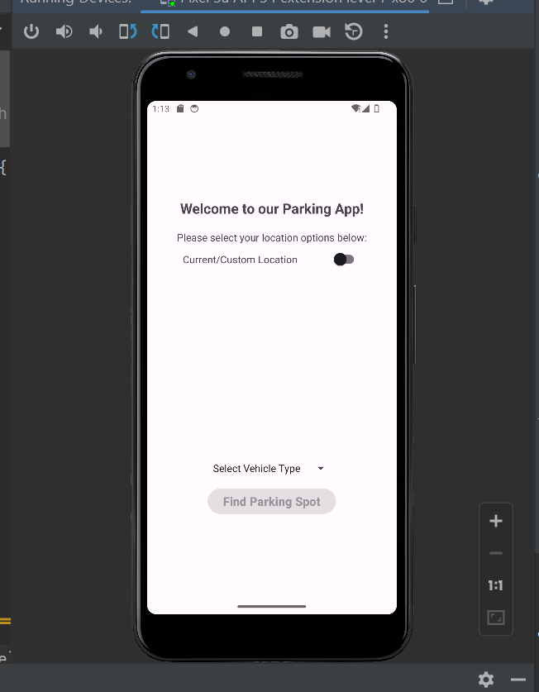

Fig3.3Starting page

CHAPTER 4 RESULT

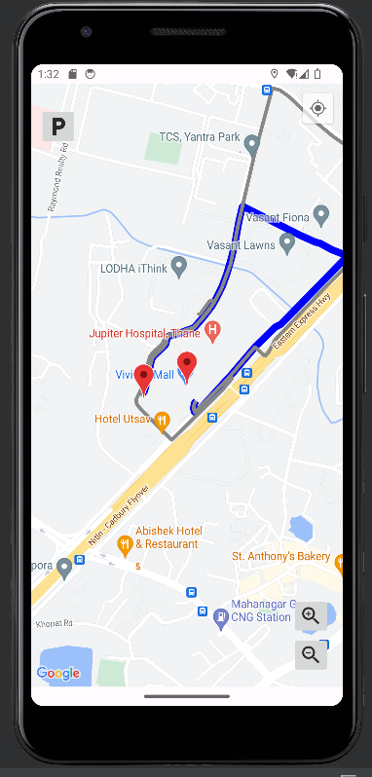

Fig 4.1 Showing route for parking

CHAPTER 5 CONCLUSION

Parking assistance system apps have emerged as valuable tools in addressing the parking challenges of urban areas. Their technological components and user-friendly interfaces make them a practical solution for both drivers and parking facility operators. As urbanization continues, the development and refinement of these apps will be crucial in ensuring efficient parking management and a smoother urban commuting experience.
In summary, parking assistance system apps have the potential to revolutionize the way we approach parking in our cities, offering significant benefits to both individual drivers and society at large. Ongoing research and development in this field will likely lead to even more sophisticated and effective parking solutions in the future.
.

REFERENCES

References:
- [1] https://iot.ieee.org
- [2] https://www.iotforall.com
- [3] https://www.gsma.com/iot/smart- cities/smart-parking/
- [4] www.ijsrp.org/research-paper-1215/ ijsrp-p4898.pd
- [5] https://www.sciencedirect.com/science
- [6] https://electronicsofthings.com/expert- opinion/smart-city-solutions-smart- parking-lots
- [7] https://www.researchgate. net/303842610_loT_based_Smart_ Parking System

